BIT3208: Advanced Web Design and Development

STUDENT DETAILS
Student Name: Joan Wairimu Muchiri
Admission Number: BSCCS/2024/53575
Course/Class: Computer Science
Unit Code: BIT3208
Unit Name: Advanced Web Design and Development
Lecturer Name: Nyoro Michael
Semester/Academic Year: 3.2

PROJECT DETAILS
Project Title: Supplier Verification System

Selected Technologies:
- HTML – Structure and markup of all system pages
- CSS – Styling and responsive layout design
- JavaScript – Client-side validation and interaction
- PHP – Server-side processing and authentication
- MySQL – Relational database for data storage
- XAMPP – Local development server environment
- VS Code – Primary code editor

ONLINE PORTFOLIO / GITHUB LINK
GitHub Repository Link:
https://github.com/Joandev-commits/Supplier-verification-system

Table of Contents
Week 1: Local Environment Setup 1
Title 1
Required Evidence 1
Student Reflection 1
Week 2: Wireframes and GUI Design 1
Title 1
Required Evidence 1
Student Reflection 1
Week 3: JavaScript and PHP Basics 1
Title 1
Required Evidence 1
Student Reflection 1
Week 4: Server-Side Components 1
Title 1
Required Evidence 1
Student Reflection 1
Week 5: Database Components 1
Title 1
Required Evidence 1
Student Reflection 1

Week 1: Local Environment Setup

Title
Installation and Testing of Local Development Environment

Required Evidence
- Fig 1: XAMPP Control Panel showing both Apache and MySQL modules with green status indicators, confirming both services are running and ready to serve requests.
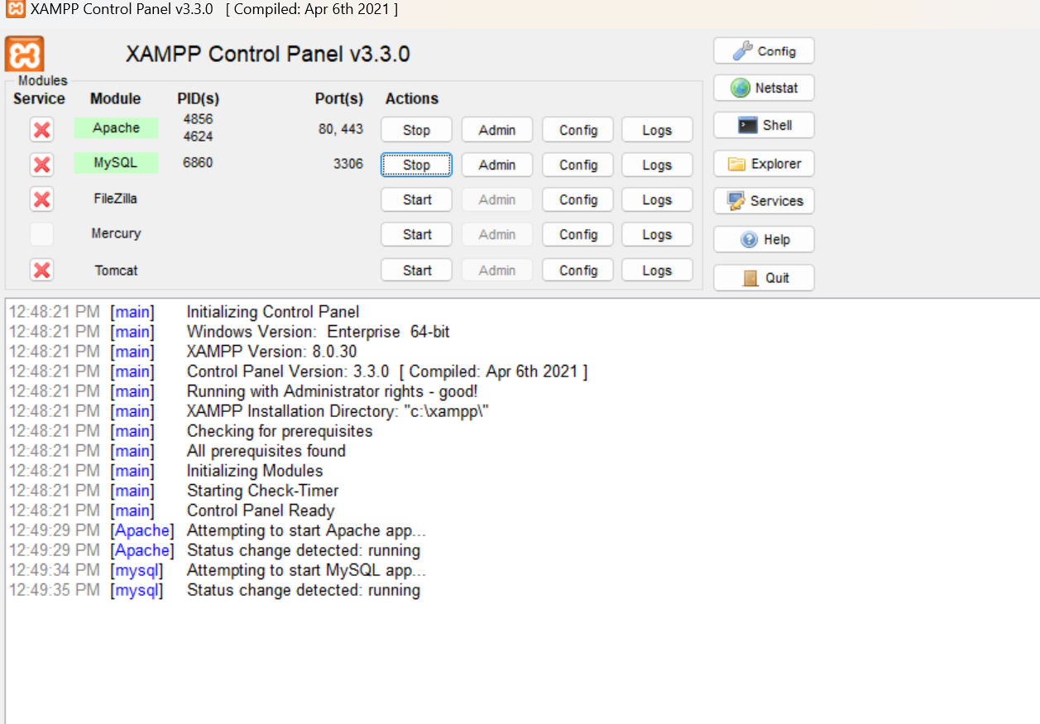
- Fig 2: Browser displaying the XAMPP localhost welcome page at http://localhost, confirming that the Apache server is correctly configured and accessible.
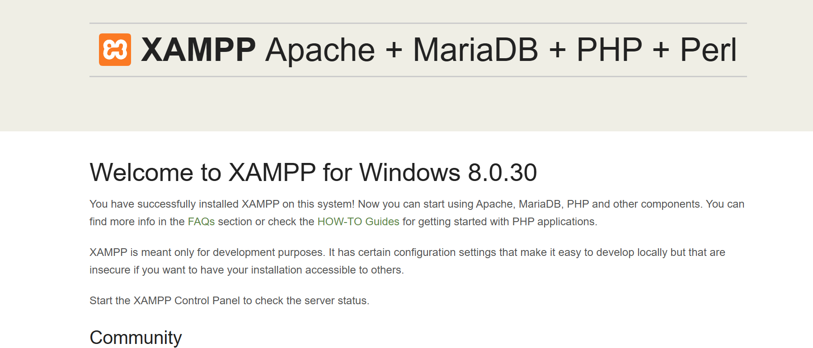
- Fig 3: PHP Hello World Test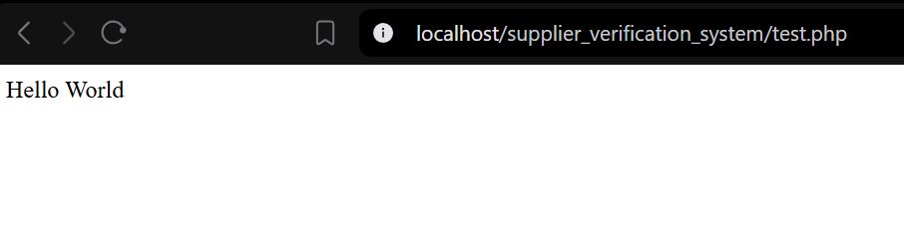Fig 4: PHP script output confirming a successful database connection usingmysqli_connect() to a MySQL database,
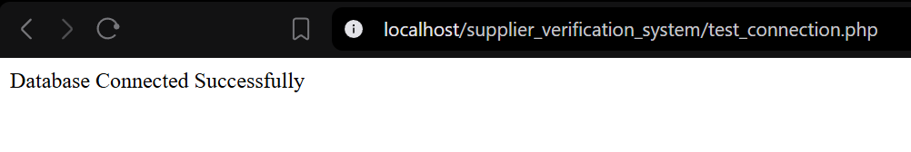

Student Reflection
During this week, I installed XAMPP to set up a local development environment on my machine. I learned how localhost works as a simulated web server environment, allowing PHP scripts to be tested without internet hosting. The technologies used were XAMPP, Apache, MySQL, and PHP. A key challenge I encountered was ensuring that both Apache and MySQL services started without port conflicts, which required checking that no other applications were using the same ports. Fig 5 demonstrates a successful database connection established using mysqli connect (), confirming that PHP can communicate with the MySQL server a critical foundation for the Supplier Verification System's data management features.

Week 2: Wireframes and GUI Design

Title
User Interface Planning and System Design

Required Evidence
- Fig 2: Admin and procurement dashboard layout design
- 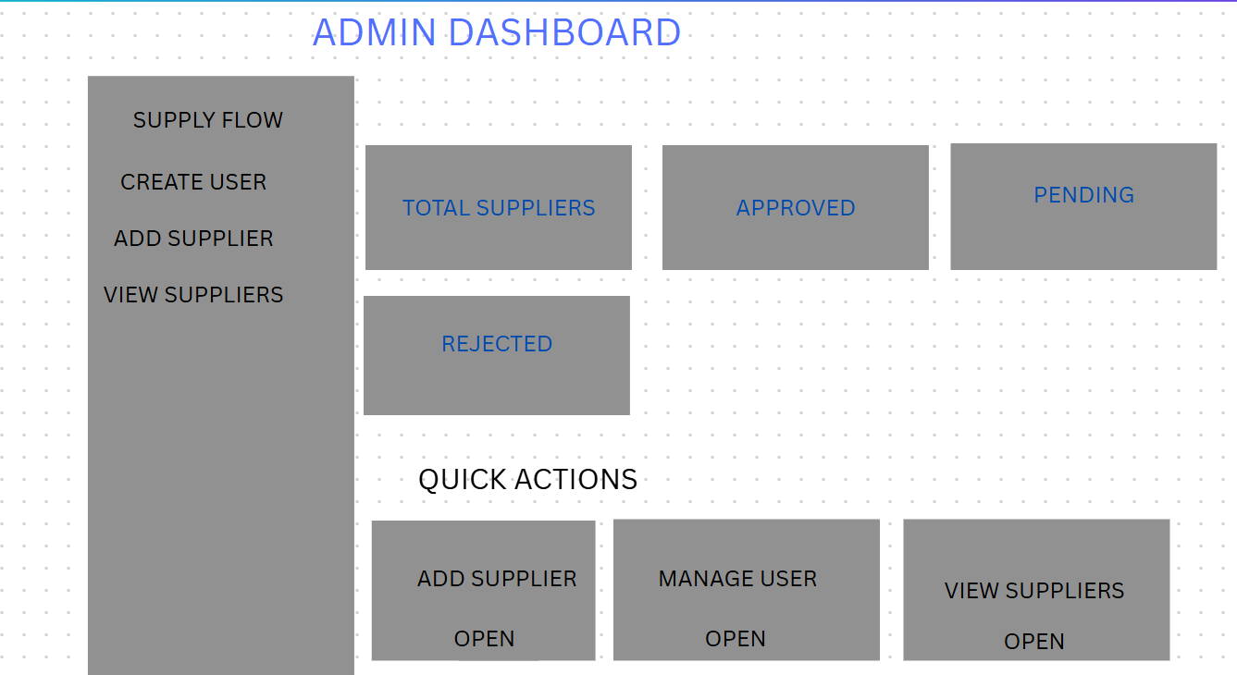
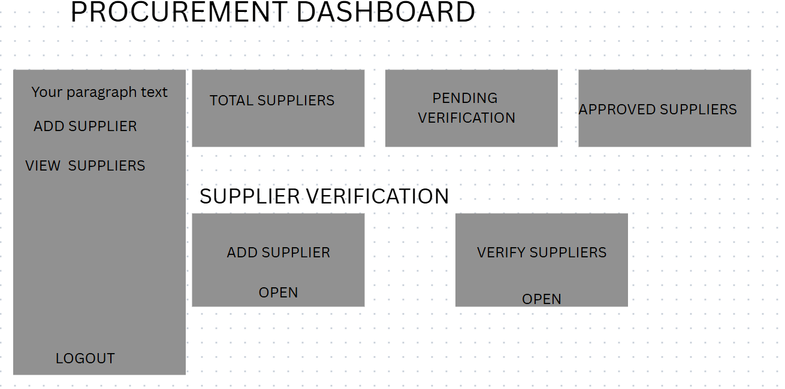
- Fig 3: Mobile view mockup demonstrating a responsive homepage layout, showing how the navigation and content areas adapt for smaller screen widths.

- Fig 4: Color theme and navigation structure
- 
- Fig 5: GUI Prototype in Draw.io

- 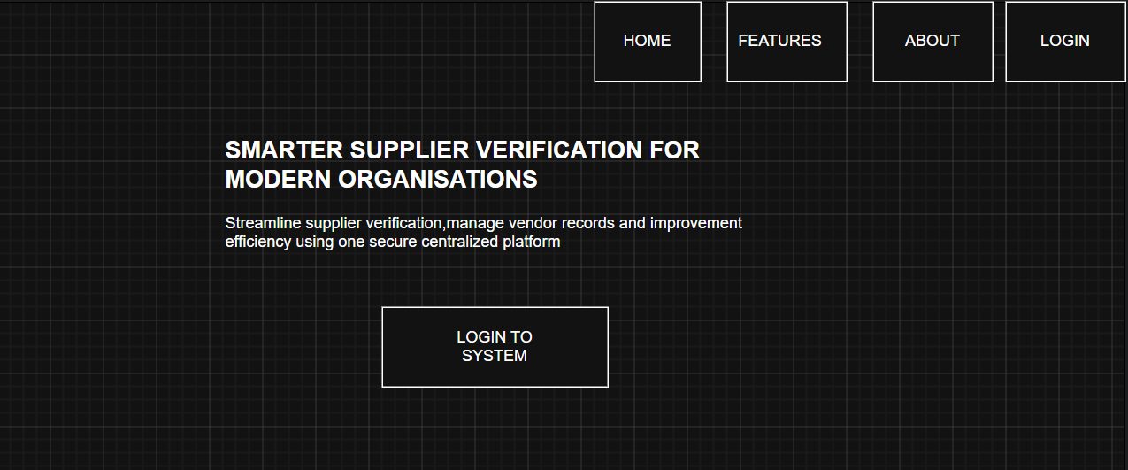

Student Reflection
The homepage and dashboard layout were designed with the intended users in mind: an admin and procurement officers who need quick access to supplier records and verification status. A left-side navigation menu was chosen because it scales more easily as new modules are added. The color theme was selected to convey professionalism and clarity, reducing visual noise for users who manage the system regularly. Fig 3 demonstrates that mobile responsiveness was planned from the beginning to ensure the system remains accessible on different devices. The wireframes guided the development so that coding began with a clear, approved structure rather than improvised layouts.

Week 3: JavaScript and PHP Basics

Title
Frontend Interaction and Backend Foundations

Required Evidence
- Fig 1: Login form with JavaScript validation active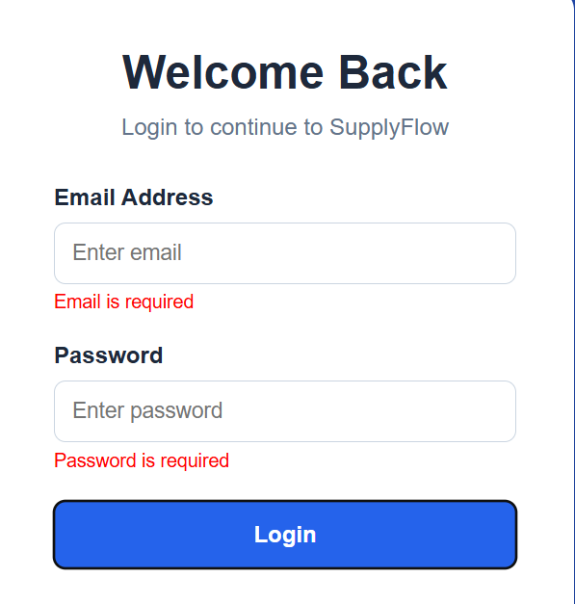
- Fig 2: Password strength checker output
- 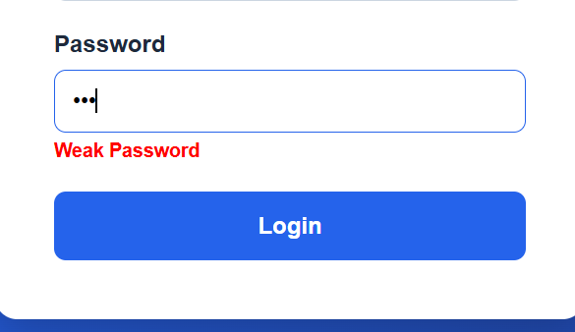
- Fig 3: PHP syntax practice file open in VS Code, showing basic PHP variables, conditional statements, and output functions used as a foundation for backend logic.
- 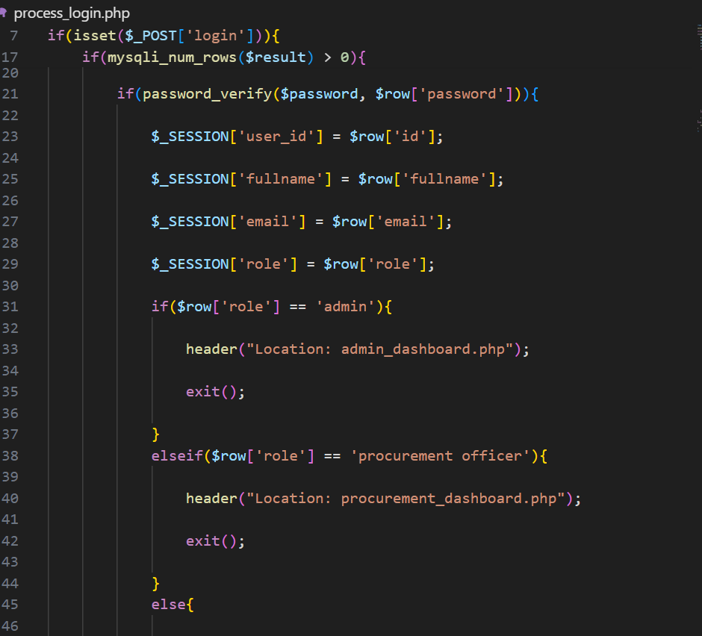
- Fig 4: db_connect.php file showing the mysqli connect() function with the correct database credentials, confirming that a reusable database connection script has been created for use across system pages. 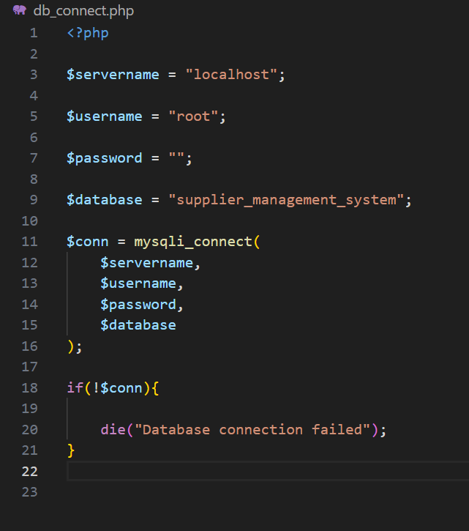
- Fig 5: Dynamic User Input Handling
- 

Student Reflection
JavaScript was used on the frontend to validate form inputs before any data is sent to the server, which is important because it reduces unnecessary server requests and gives users immediate feedback on errors. PHP handled the backend processing of submitted form data, and the database connection script in Fig 4 establishes how the system will consistently access MySQL records throughout the project. A key challenge was understanding the difference between client side validation, which runs in the browser, and server-side processing, which runs on the XAMPP server. This distinction matters because client-side validation can be bypassed, so PHP level checking will also be implemented in later weeks.

Week 4: Server-Side Components

Title
PHP Authentication and Session Management

Required Evidence
Fig 1: Admin user registration page
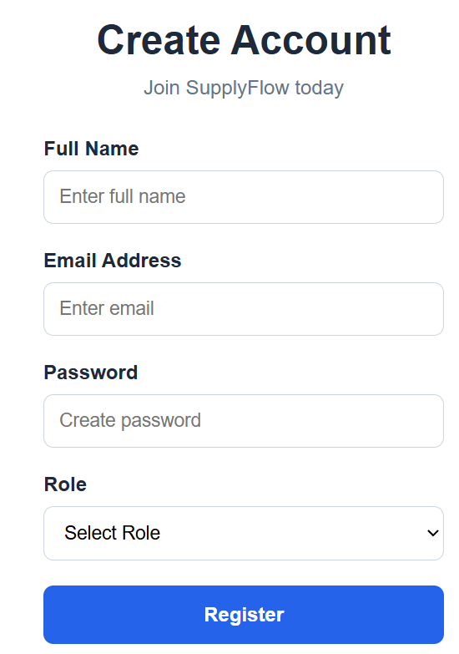
Fig 2: Login page
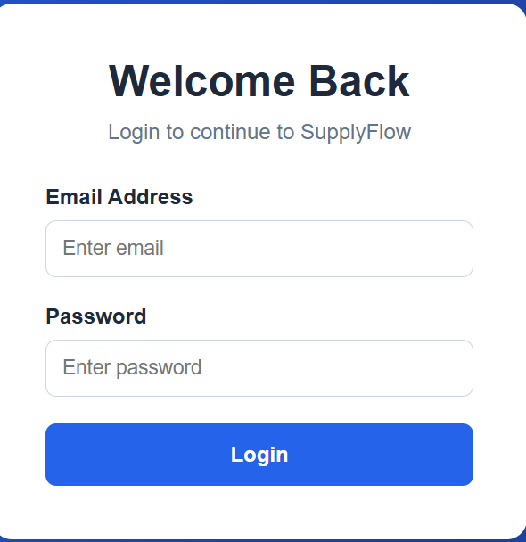
- Fig 3: Password hashing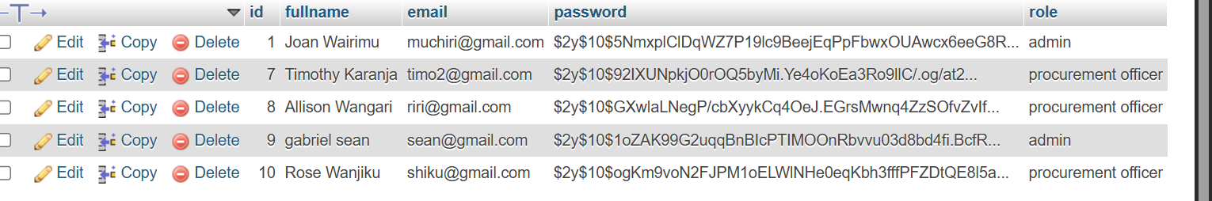
- Fig 4: Admin dashboard
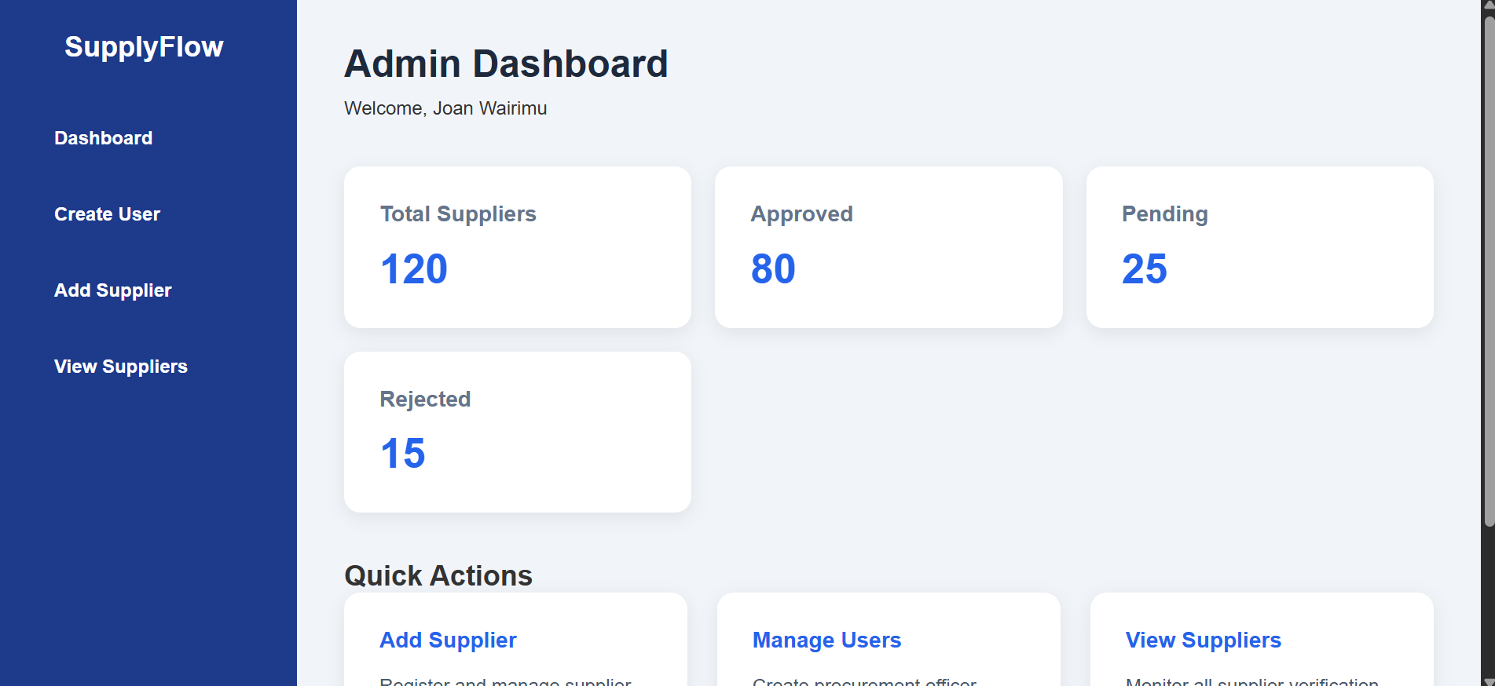
- Fig 5: Procurement officer dashboard
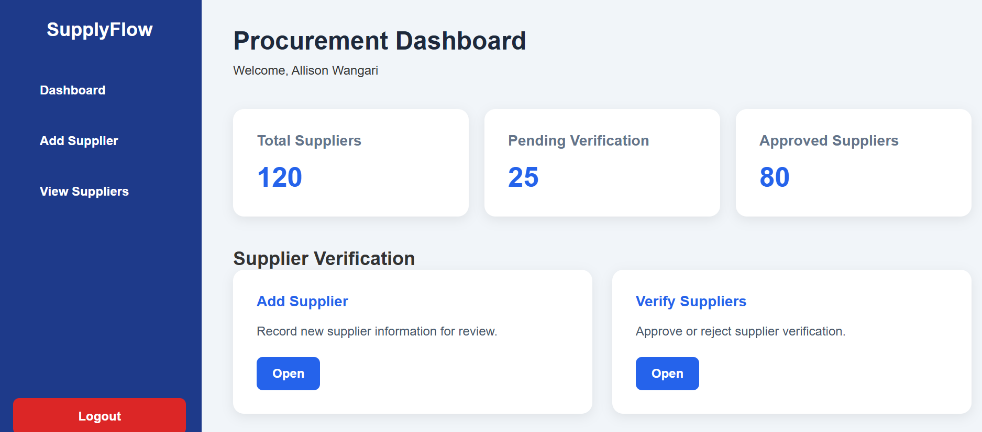
- Fig 6: session_check.php file open in VS Code
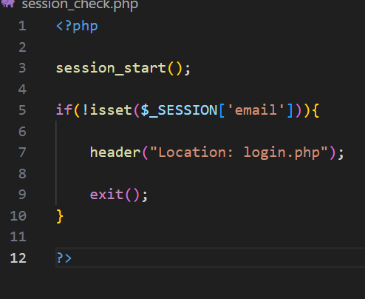

Student Reflection
This week focused on building the authentication layer of the Supplier Verification System. PHP sessions were used to maintain user login state across pages, so once a user logs in, their identity is remembered until they log out or the session expires. Password hashing using password hash() was implemented to ensure that even if the database is compromised, actual passwords cannot be recovered directly. A challenge encountered was implementing role-based access correctly so that admins and procurement officers see different dashboards after login. Fig 5 shows the session_check.php script which is included at the top of every protected page to redirect unauthenticated users back to the login page.

Week 5: Database Components

Title
MySQL Database Integration and CRUD Operations

Required Evidence
- Fig 1: Users table structure.
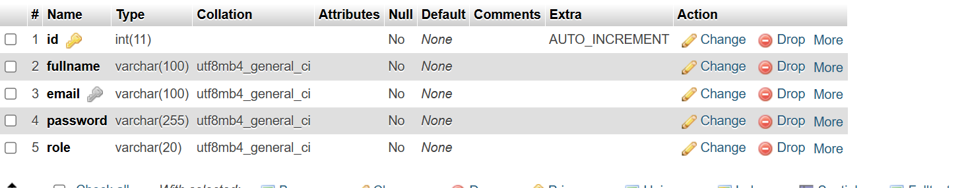
- Fig 2: suppliers table structure.
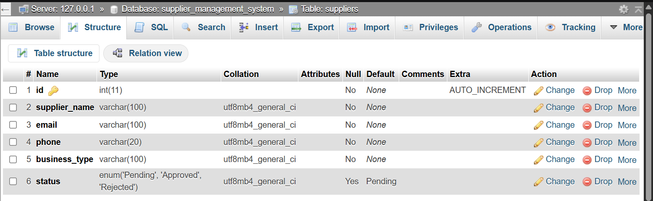
- Fig 3: Add Supplier page
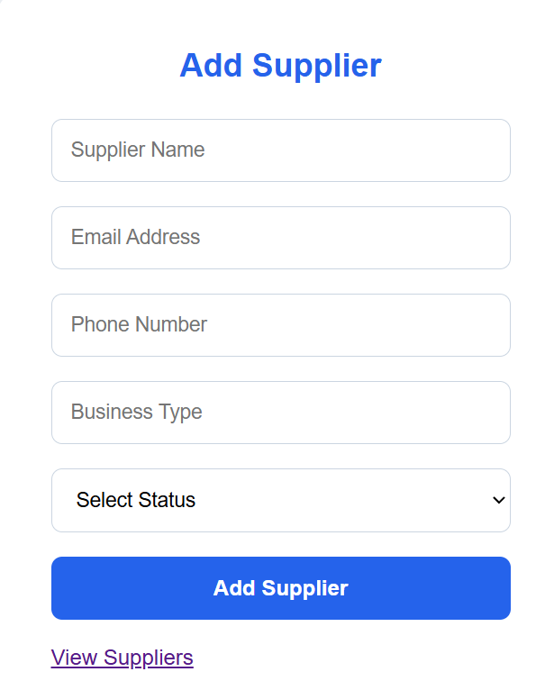
- Fig 4: View Suppliers page.
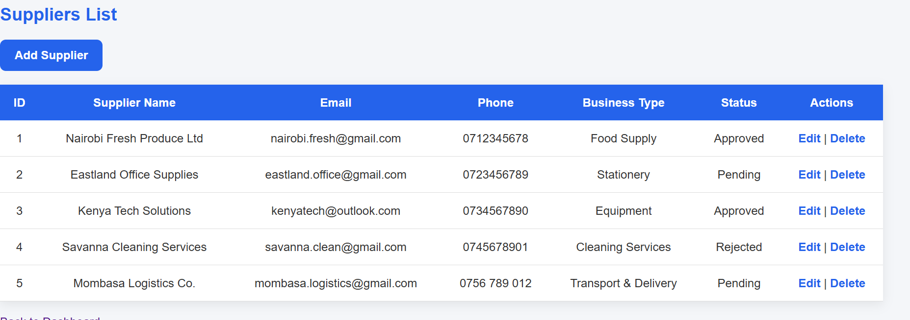
Fig 5: Edit supplier page
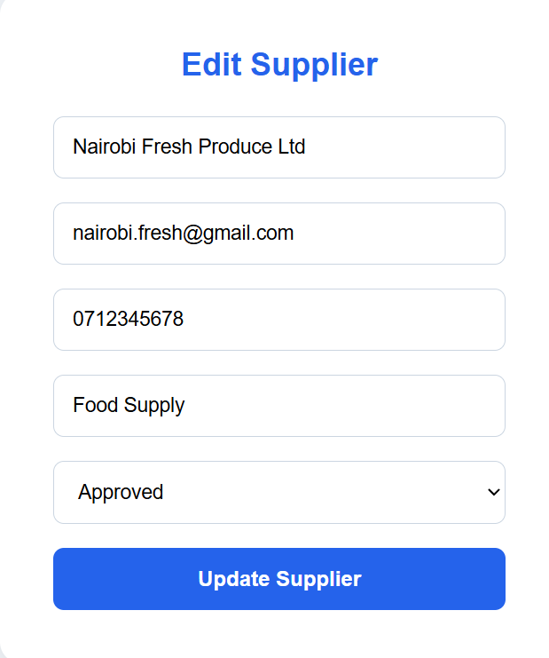
Fig 6: Delete supplier operation
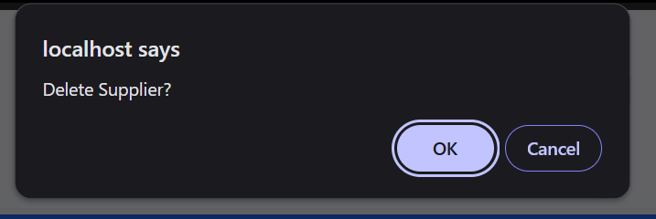

Student Reflection
Week 5 focused on connecting the Supplier Verification System to the MySQL database using PHP. CRUD operations were implemented to allow users to add, view, edit, and delete supplier records from the system. The users and suppliers’ tables were created in phpMyAdmin to store system data properly. One challenge encountered was loading existing supplier details into the edit form before updating the information in the database. Fig 4 shows supplier records being retrieved dynamically from the database and displayed in a table using PHP. By the end of the week, the system was able to manage supplier records successfully.

